Design Document:
RFID Trigger Configuration & Event Subscription (dev2.0.2)

1. Overview
The RFIDHandler class manages the Zebra RFID reader's hardware trigger, which serves two distinct functions depending on the application state:
- RFID Mode: The trigger starts/stops RFID tag inventory.
- Barcode (Sled Scan) Mode: The trigger activates the barcode scanner.
To support these modes, the application dynamically reconfigures the hardware key layout and manages event subscriptions. This document details the design of setTriggerEnabled (hardware config) and subscribeRfidHardwareTriggerEvents(software event masking, actual method name in code).

2. Architecture & Synchronization

2.1. The Challenge
Reconfiguring the hardware trigger (setKeylayoutType) involves sending commands to the reader. If the reader is currently performing an inventory (busy) or if multiple threads attempt to configure it simultaneously, the SDK may throw exceptions or the reader may enter an undefined state.

2.2. Synchronization Strategy
To ensure thread safety and hardware stability, we use a lock + busy-guard strategy, with bounded waiting reserved for default restore operations.
- resourceLock (ReentrantLock): Ensures mutual exclusion. Only one configuration operation can proceed at a time.
- bRfidBusy (volatile boolean): Acts as a guard. Configuration commands are blocked until this flag is false (indicating the reader is idle).
- waitForReaderIdle(): A bounded helper used by restoreDefaultTriggerConfig() to avoid waiting indefinitely while the reader is busy.

3. Detailed Design

3.1 Busy Guard Logic: bRfidBusy
- Purpose: bRfidBusy is a volatile boolean flag in RFIDHandler that acts as a concurrency guard, indicating whether the RFID reader is currently busy (performing inventory or other operations). It prevents trigger configuration changes and inventory operations from being attempted while the reader is active, ensuring thread safety and hardware stability.
- Lifecycle (Set to true): On receiving INVENTORY_START_EVENT in the status event handler, bRfidBusy is set to true.
- Lifecycle (Set to false): On receiving INVENTORY_STOP_EVENT, bRfidBusy is set to false.
- Usage (Guard for Configuration): Before any trigger mode/configuration change (e.g., in setTriggerEnabled or restoreDefaultTriggerConfig), the code checks bRfidBusy. If true, the operation is rejected, inventory is stopped, and the UI is notified to retry.
- Usage (Wait for Idle): The waitForReaderIdle() helper method polls bRfidBusy with a timeout to ensure the reader is idle before proceeding with configuration changes.
- Rationale: Prevents race conditions and SDK errors by ensuring only one operation is active at a time. Ensures that trigger mode switches and configuration changes are only performed when the reader is idle. Provides a robust, thread-safe mechanism for synchronizing hardware state with application logic.
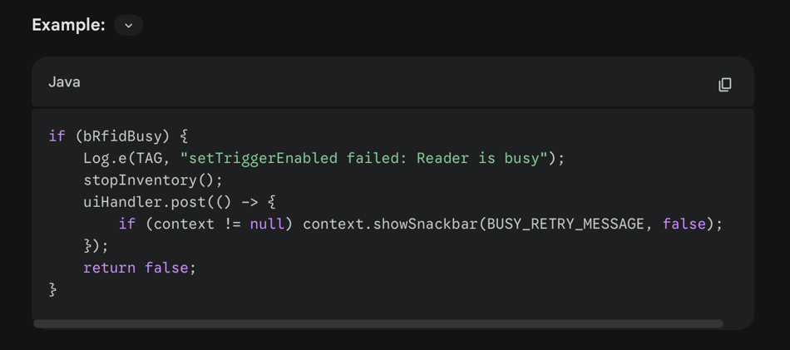
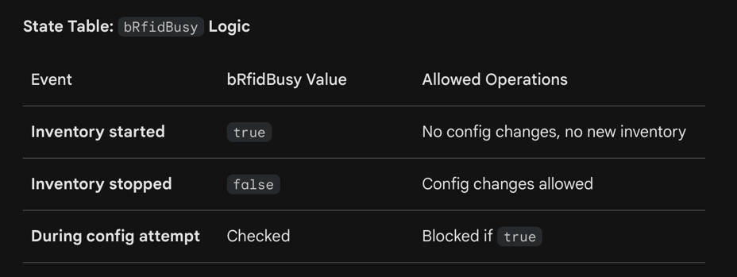
Note: This logic is essential for safe, deadlock-free trigger switching and reliable operation in concurrent environments.

3.2 Design and Usage of bSwitchFromRfidToBarcode:
- Purpose: bSwitchFromRfidToBarcode is a volatile boolean flag in RFIDHandler that controls the transition of trigger event handling from RFID mode to Barcode mode. It is used to prevent RFID trigger events from being processed when the system is in the process of switching to barcode scanning, especially during test or mode-switch scenarios.
- Declaration: private volatile boolean bSwitchFromRfidToBarcode = false;
- Usage (Set to true): In the RFID event handler, when an inventory stop event occurs and the system is in test mode (context.getTestStatus()), the flag is set to true to indicate that the next trigger events should be ignored by the RFID logic and handled by the barcode logic instead.
- Usage (Set to false): When switching back to RFID mode (e.g., after successful trigger configuration for RFID), the flag is reset to false.
- Usage (Checked): In the RFID trigger event handler, if bSwitchFromRfidToBarcode is true, all RFID trigger events are ignored.
- Design Rationale: Prevents trigger event debounce and race conditions when switching between RFID and Barcode modes. Ensures that after an inventory stop (especially in test mode), the hardware trigger is not processed by the RFID logic, but instead is handed off to the barcode logic. Provides a clear, thread-safe mechanism for mode switching in the event-driven architecture.

Sequence Example:
- RFID Inventory Stop Event: Inventory stops, and if in test mode, bSwitchFromRfidToBarcode is set to true.
- Trigger Event: If a hardware trigger event occurs, the RFID handler checks the flag. If true, it ignores the event.
- Barcode Test: The system disables RFID trigger events, configures the trigger for barcode, and barcode scanning is enabled.
- Switch Back to RFID: When switching back, the flag is reset to false.
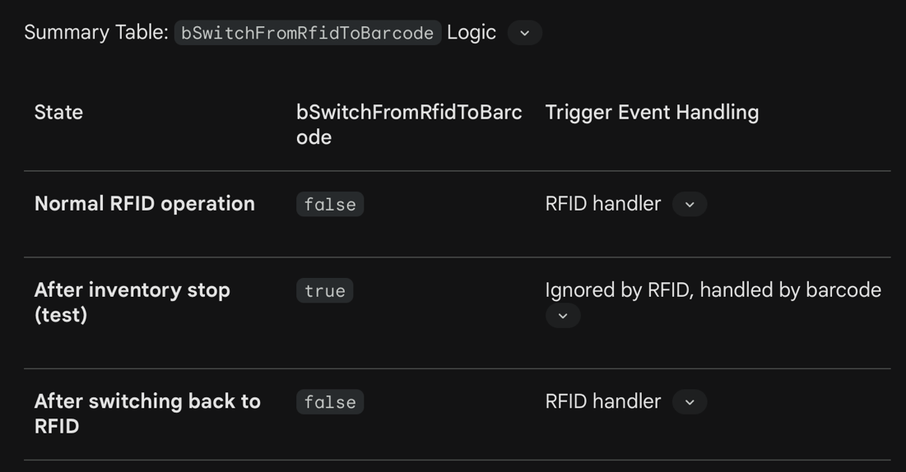
Note: This design ensures robust and predictable trigger event handling when toggling between RFID and Barcode modes, minimizing the risk of unintended operations or race conditions.

3.3. Physically reconfigures the reader's hardware trigger behavior:

setTriggerEnabled(boolean isRfidEnabled)

Workflow:
- Acquire Lock: Enters resourceLock to block other configuration attempts.
- Check Busy Guard: If bRfidBusy is true, operation is rejected immediately, inventory stop is requested, and UI gets a retry message.
- Determine Mode: true routes to ENUM_NEW_KEYLAYOUT_TYPE.RFID (Trigger starts RFID Inventory). false routes to ENUM_NEW_KEYLAYOUT_TYPE.SLED_SCAN (Trigger activates Barcode Scanner).
- Apply Configuration: Calls reader.Config.setKeylayoutType(mode, mode).
- Align Event Subscription: On success, calls subscribeRfidHardwareTriggerEvents(isRfidEnabled) to keep software events consistent with hardware mode. (Note: This is always called from within setTriggerEnabled in the implementation.)
- Release Lock: Ensures the lock is released in a finally block.
- bSwitchFromRfidToBarcode: When switching from RFID to Barcode, this flag is set to ignore trigger events during the transition (implementation detail).

3.4 The method: subscribeRfidHardwareTriggerEvents(boolean enable)
- Purpose: Controls whether the application receives HANDHELD_TRIGGER_EVENT notifications from the SDK. This allows the app to dynamically enable or disable trigger event handling based on the current mode (RFID or Barcode).
- Usage (Enable - true): The app receives callbacks when the trigger is pressed/released. This is essential for RFID mode to programmatically start/stop inventory.
- Usage (Disable - false): The app ignores trigger events. This is useful when switching to Barcode mode to prevent the RFID logic from reacting to trigger presses intended for the scanner.
- Integration (Switching from RFID to Barcode): Call subscribeRfidHardwareTriggerEvents(false) to immediately stop handling trigger events in RFID logic. Call setTriggerEnabled(false) to reconfigure the hardware for barcode scanning.
- Integration (Switching from Barcode to RFID): Call setTriggerEnabled(true) to reconfigure the hardware for RFID. On success, subscribeRfidHardwareTriggerEvents(true) is called automatically to resume RFID trigger event handling.
- Rationale: Prevents race conditions and unwanted inventory operations during mode transitions. Ensures that trigger events are only handled by the correct subsystem (RFID or Barcode) at the right time.
Example:
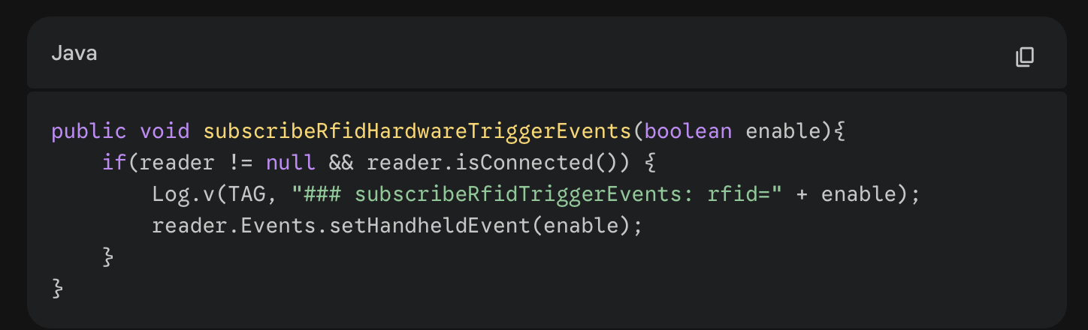
Note: This method is a key part of the safe trigger mode switch workflow and must be called in the correct sequence to avoid spurious or missed trigger events.

4. Integration Workflow
When switching modes (e.g., from RFID to Barcode), these methods should be used in a specific sequence to ensure a clean transition.
Scenario: Switching to Barcode Mode
- Unsubscribe Events: Call subscribeRfidHardwareTriggerEvents(false). Reason: Stop the RFIDHandler from receiving "Pressed" events immediately, preventing it from trying to start an RFID inventory while we are reconfiguring.
- Reconfigure Hardware: Call setTriggerEnabled(false). Reason: Tell the hardware that the trigger should now act as a scanner button. The implementation sets bSwitchFromRfidToBarcode to ignore trigger events during this transition.
Scenario: Switching to RFID Mode
- Reconfigure Hardware: Call setTriggerEnabled(true). Reason: Tell the hardware the trigger is for RFID. On success, subscribeRfidHardwareTriggerEvents(true) is called automatically by setTriggerEnabled.

5. Safety Mechanisms
Mechanism | Purpose
ReentrantLock | Prevents restoreDefaultTriggerConfig and setTriggerEnabled from running concurrently.
waitForReaderIdle | Prevents sending restore-default commands while the radio is active (inventorying, write, read access, etc.).
Timeout (~3s) | Prevents hangs if the reader remains busy/stuck during restore-default workflow.
Try-Catch-Finally | Ensures locks are always released, even if the SDK throws an unexpected exception.
Export to Sheets

6. Deadlock-Avoidance Contract
To keep trigger mode changes safe under concurrent events, the implementation follows these rules:
- Never block indefinitely while holding resourceLock: waitForReaderIdle() has bounded retries and fails fast with TimeoutException.
- Never require event thread locks for busy-state transitions: bRfidBusy is volatile and updated directly by status events.
- Always release lock on every path: setTriggerEnabled and restoreDefaultTriggerConfig unlock in finally.
- Switch order is intentional: RFID→Barcode unsubscribes RFID trigger events before hardware switch. Barcode→RFID applies hardware mode and enables RFID trigger events on successful configuration.
These rules prevent circular waiting between trigger event handling and trigger configuration APIs.

7. Code Reference
public boolean setTriggerEnabled(boolean isRfidEnabled) {
resourceLock.lock();
try {
if (reader == null || !reader.isConnected() || context == null) return false;

if (bRfidBusy) {
Log.e(TAG, "setTriggerEnabled failed: Reader is busy");
stopInventory();
uiHandler.post(() -> {
if (context != null) context.showSnackbar(BUSY_RETRY_MESSAGE, false);
});
return false;
}

Log.d(TAG, "### setTriggerEnabled: rfid=" + isRfidEnabled);
ENUM_NEW_KEYLAYOUT_TYPE mode = isRfidEnabled ?
ENUM_NEW_KEYLAYOUT_TYPE.RFID : ENUM_NEW_KEYLAYOUT_TYPE.SLED_SCAN;

try {
Log.v(TAG, "### before setTriggerEnabled: rfid=" + isRfidEnabled);
RFIDResults result = reader.Config.setKeylayoutType(mode, mode);
ENUM_NEW_KEYLAYOUT_TYPE upperTriggerValue2 = reader.Config.getUpperTriggerValue();
ENUM_NEW_KEYLAYOUT_TYPE lowerTriggerValue2 = reader.Config.getLowerTriggerValue();
Log.v(TAG, "### After setTriggerEnabled...");
logTriggerValues(upperTriggerValue2, lowerTriggerValue2);
Log.v(TAG, "### after setTriggerEnabled: rfid=" + isRfidEnabled);

if (result == RFIDResults.RFID_API_SUCCESS) {
Log.v(TAG, "#################################################");
Log.v(TAG, "Trigger configuration success: " + mode.name());
Log.v(TAG, "#################################################");

// On success, calls subscribeRfidHardwareTriggerEvents(isRfidEnabled)
subscribeRfidHardwareTriggerEvents(isRfidEnabled);

if(isRfidEnabled) {
bSwitchFromRfidToBarcode = false;
}
return true;
} else {
Log.e(TAG, "Trigger configuration failed: " + result.toString());
}
} catch (InvalidUsageException | OperationFailureException e) {
stopInventory();
uiHandler.post(() -> {
if (context != null) context.showSnackbar(BUSY_RETRY_MESSAGE, false);
});
Log.e(TAG, "Exception in setTriggerEnabled", e);
}
return false;
} finally {
resourceLock.unlock();
}
}

Release & History
- dev2.0.2 (2026-02-18):
  - Major release for Trigger Sync and deadlock-safe switching.
  - Improved concurrency and lock-guarded trigger switching.
  - Updated all documentation and markdown files for new architecture and release.
  - All code and docs ready for dev2.0.2 tag and push.
  - See history.md and README.md for previous release notes and usage instructions.

